**USER MANUAL**

**ACADEMY MOVIES**



Contents

Login 4

Main Menu 5

Administration Menu 6

Employee Audit 7

Login Audit 8

Order Audit 9

System Users 10

Personnel Submenu 11

Employees 12

Personnel Report 16

Paystub 17

Deduction 18

Department 19

Position 20

Skills 21

Purchasing Submenu 22

Purchase Order 23

Purchase Order Register 24

Inventory Submenu 25

Supplier List 26

Warehouse 27

Genre 28

Distributor 29

Inventory Report 30

Films 31

Advanced Search for Films 33

Actors 34

Directors 35

Sales Submenu 36

Accounting Submenu 36

Client Order 37

Commissions 38

Approve Client 39

# Login

The Academy Movies System starts with a login page.



# Main Menu

Once you login successfully, you will be directed to the Main Menu or the home page for the Academy Movies System. This form has links to the forms for the five departments and a link to the forms that are managed only by the administration.



Xdfzds

If you click on the Administration Button in the above form, the application will take you to the System Administration submenu.

# Administration Menu

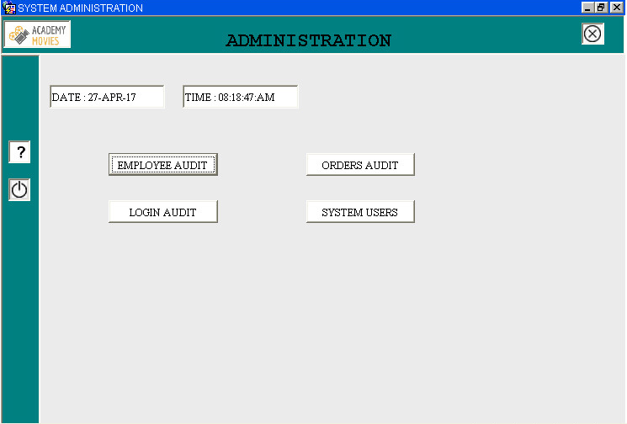

In the above submenu, you can click on any of the buttons to take you to that particular form.

# Employee Audit

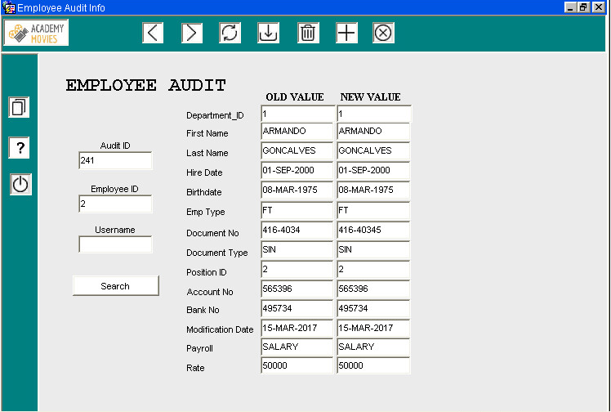

1 – Go to previous record

2 – Go to next record

3 – Reload information

4 – Save changes to the current record

5 – Delete record

6 – Add a new record

7 – Cancel and go to the previous form

# Login Audit

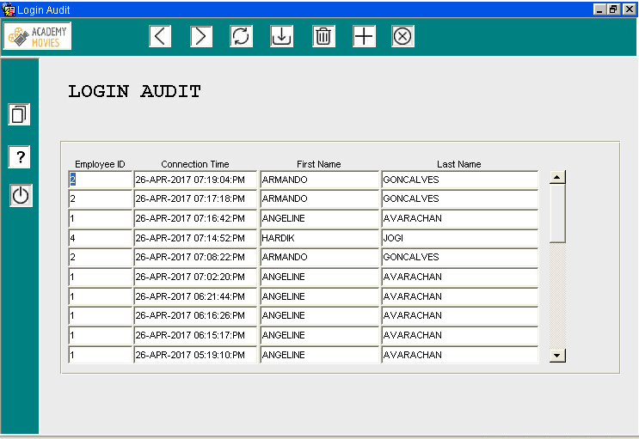

The Login Audit form automatically displays the login information of every user that has ever connected to the system. Login Audit has similar functionalities to the Employee Audit Form.

# Order Audit

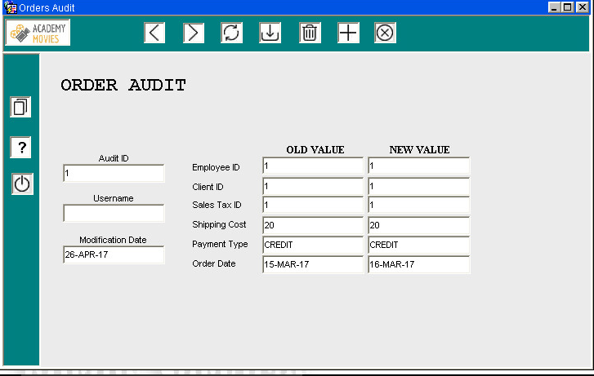

Order Audit has similar functionalities to the Employee Audit Form.

# System Users

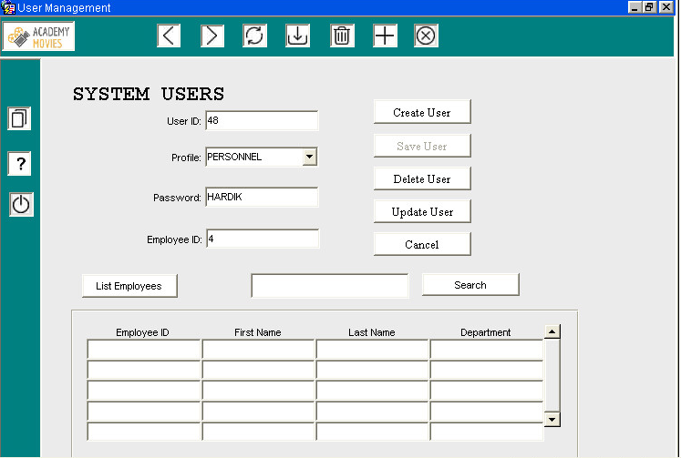

**User ID:** This field is automatically filled and it is not editable.

**Profile:** Choose the user profile.

**Password:** The password the user will need to login to the application.

**Employee ID:** Choose the user’s employee id. That number is requested in the login form.

**List Employees** button lists all the employees saved on employees table. By selecting one employee from the list, the employee_id is automatically filled.

The user can also **Search** by a specific Employee_id, First Name, Last Name or Department.

# Personnel Submenu

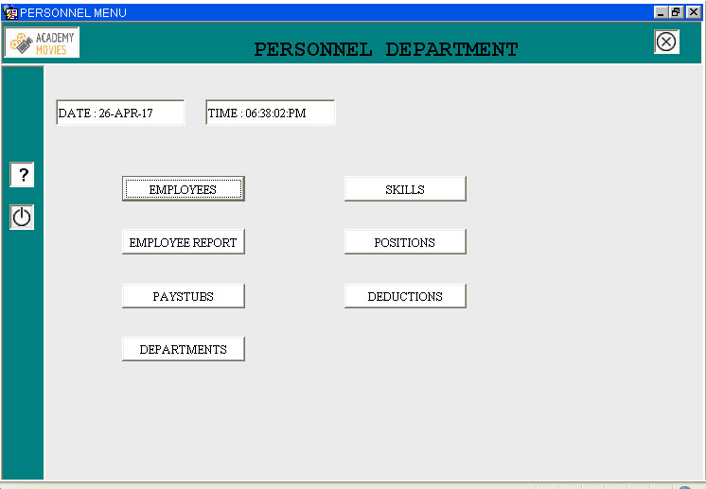

In the above submenu, you can click on any of the buttons to take you to that particular form.

If you click on ‘EMPLOYEES’, it will take you to the following form:

# Employees



1 – Go to previous record

2 – Go to next record

3 – Reload information

4 – Save changes to the current record

5 – Delete record

6 – Add a new record

7 – Cancel and go to the previous form









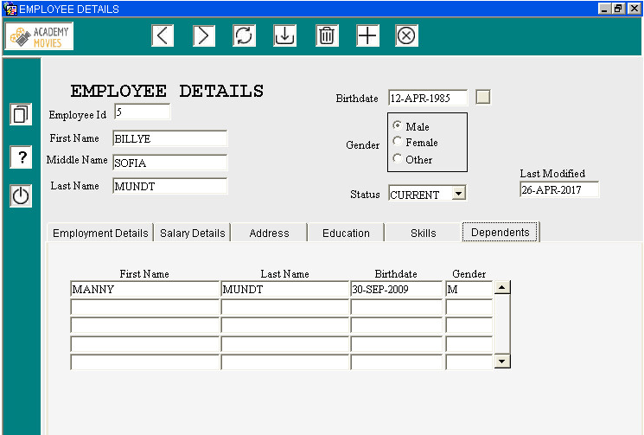

In the employee details for, you can view all the information related to an employee. You can also add/update/delete an employee in this form and the information related to each employee too.

If you click on the Report icon, it will take you to the Personnel Report.

# Personnel Report

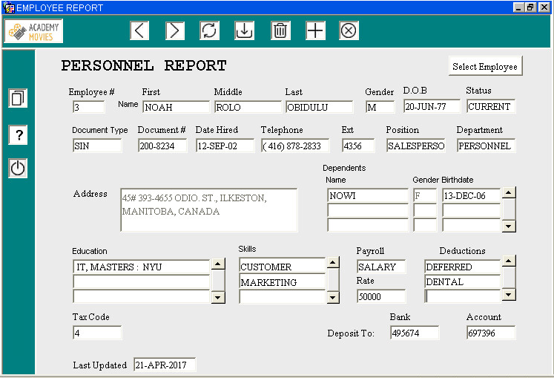

The personnel report form will display the personnel report for each employee according to the employee selected.

# Paystub



This form show the deduction, and the gross pay for each employee for a month.

# Deduction



In the above form, you can add/update/delete deduction information that exists in the company.

# Department

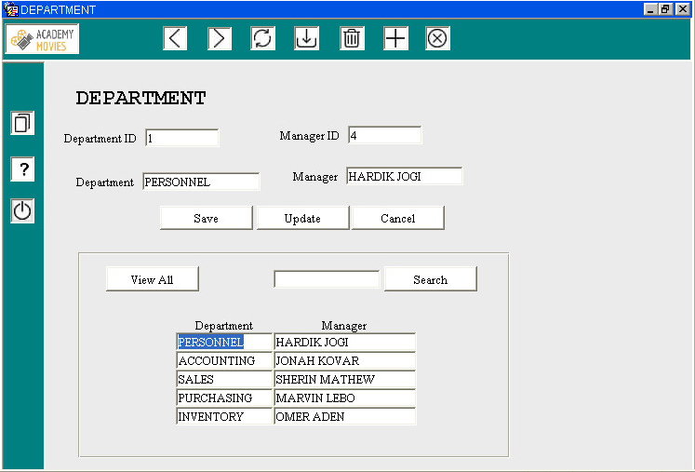

In the above form, you can view all the departments and its manager. You cannot delete any department, however you can update the manager of the department.

# Position

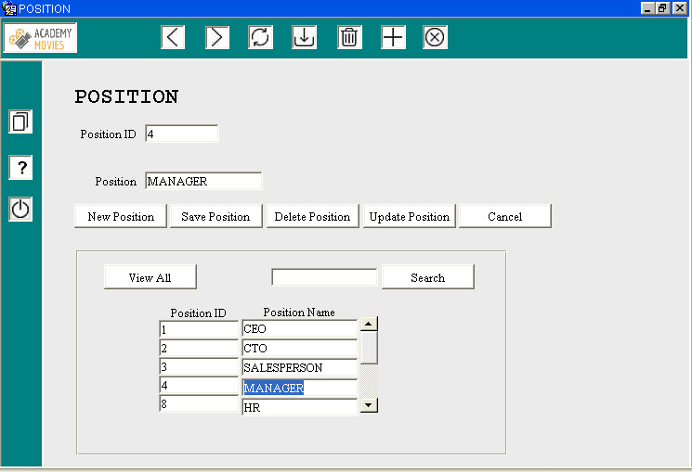

In the above form, you can view and search for positions in the company. You can also add/update/delete positions.

# Skills

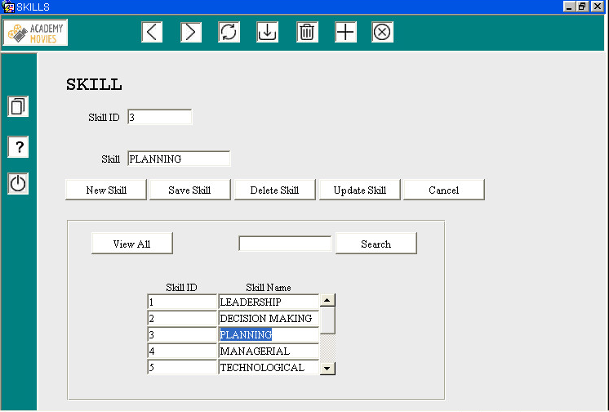

In the above form, you can view and search for skills listed in the company. You can also add/update/delete skills.

# Purchasing Submenu

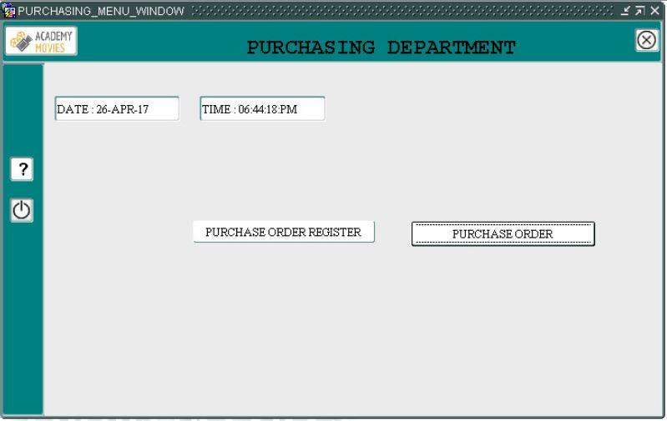

In the above submenu, you can click on any of the buttons to take you to that particular form.

# Purchase Order

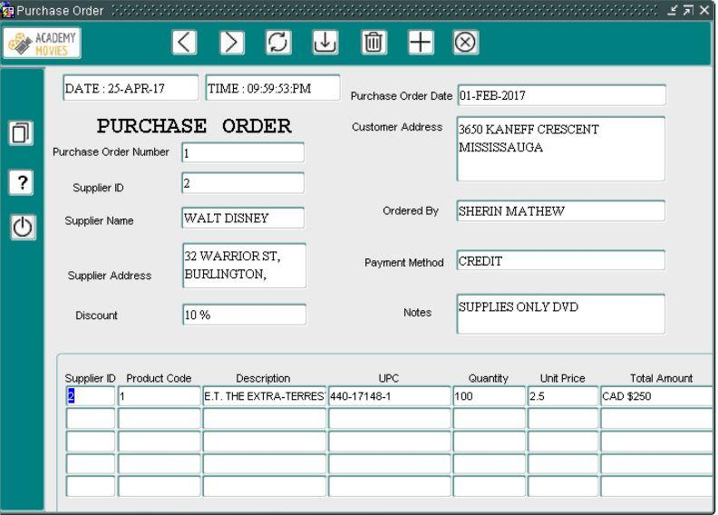

This is a purchase order report. Purchase order is generated automatically whenever the inventory quantity is low than minimum level. It shows the quantity ordered, unit price and total amount.

# Purchase Order Register

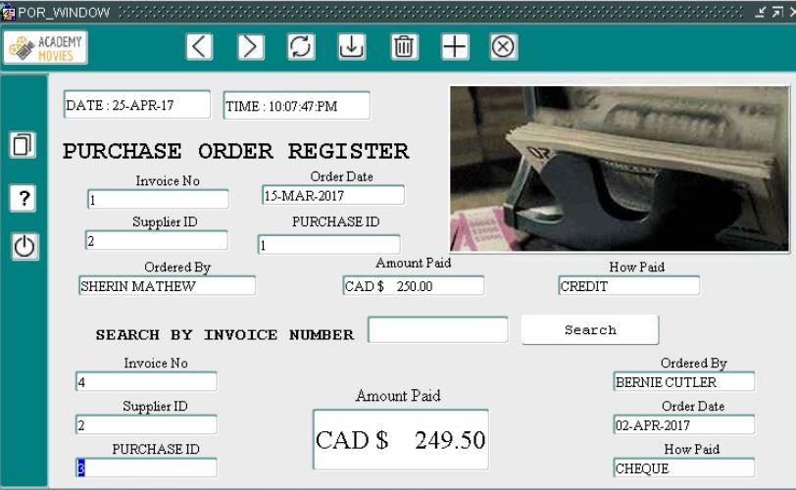

This is a report for purchase orders. It can show the user the individual invoices and search by invoice number. It can also show the sales person who ordered it, the total amount paid, and the payment method.

# Inventory Submenu

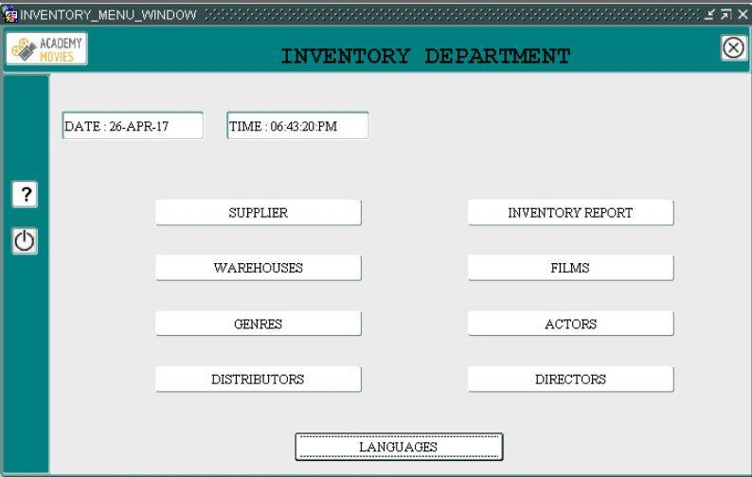

In the above submenu, you can click on any of the buttons to take you to that particular form.

# Supplier List

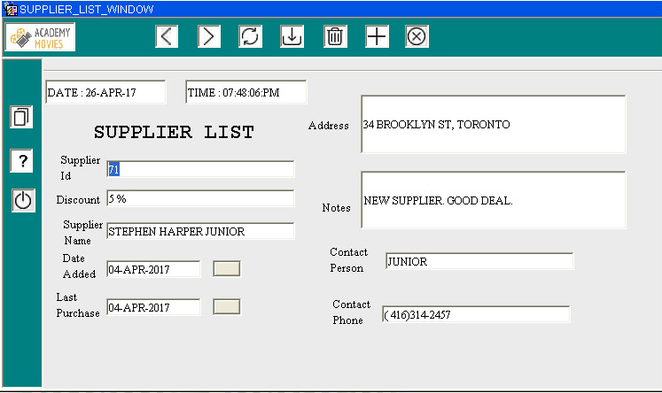

This form is used to add, view, update or delete suppliers. By default, user can view the supplier list and scroll using navigation buttons. They can even edit and update it as required. By clicking the “plus” button, user can insert new record and save it by clicking save button.

# Warehouse

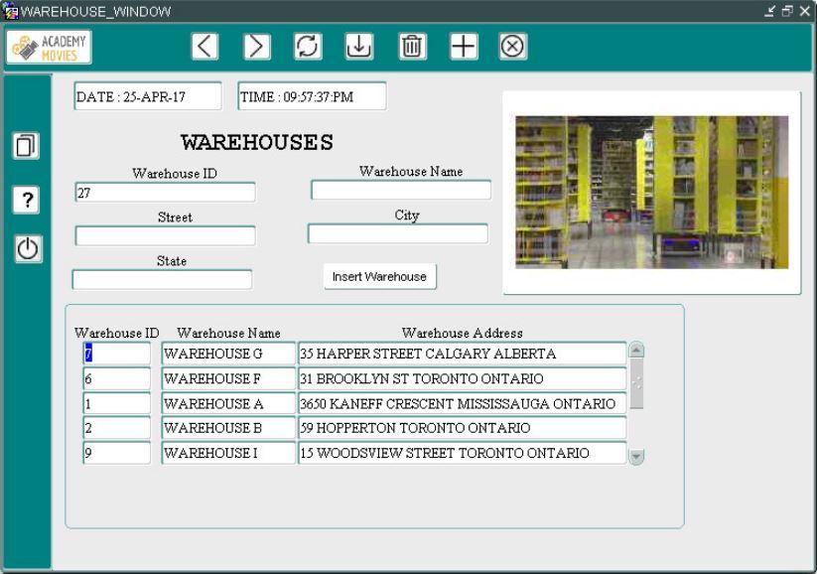

After clicking on the “add” button, go to insert block, add warehouse name, street, city and state. After that press on INSERT WAREHOUSE button. This will insert new warehouse record. Click on refresh button to check the newly added record in the report block below.

# Genre

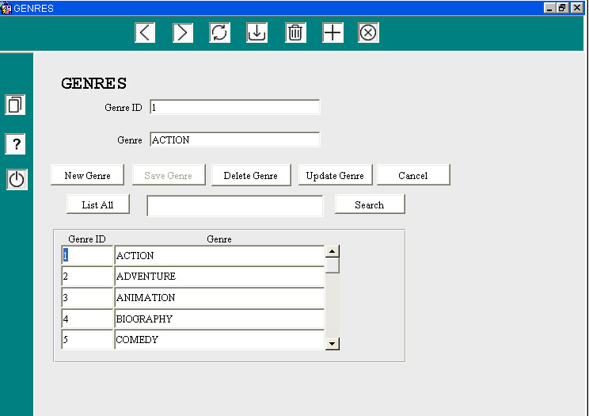

After clicking on “**List All**” to list all genres, by clicking either on genre ID or on genre the fields Genre ID and Genre are automatically field.

By clicking on “**New Genre**” the genre ID is automatically filled and the user must enter a Genre before submitting the changes to the database.

# Distributor

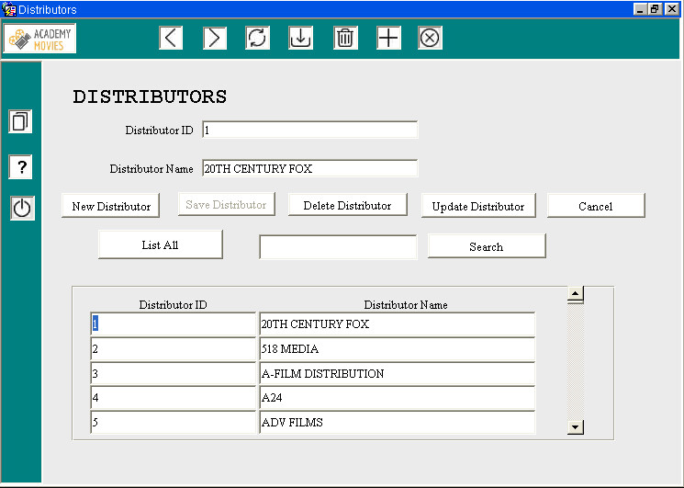

Distributors form has the same functionalities of Genres form.

# Inventory Report

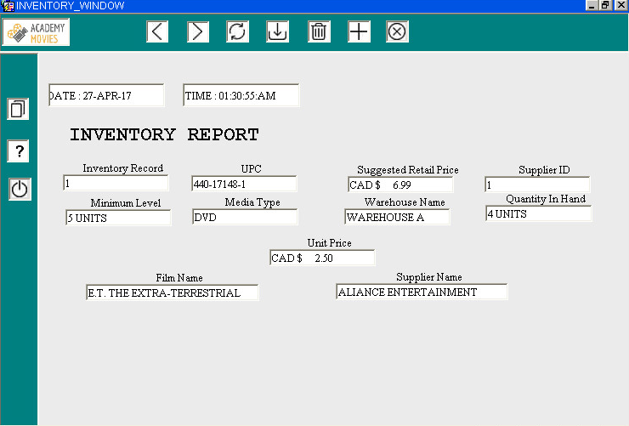

This is an Inventory report which shows the quantity of item available, minimum level, suggested retail price and unit price.

# Films

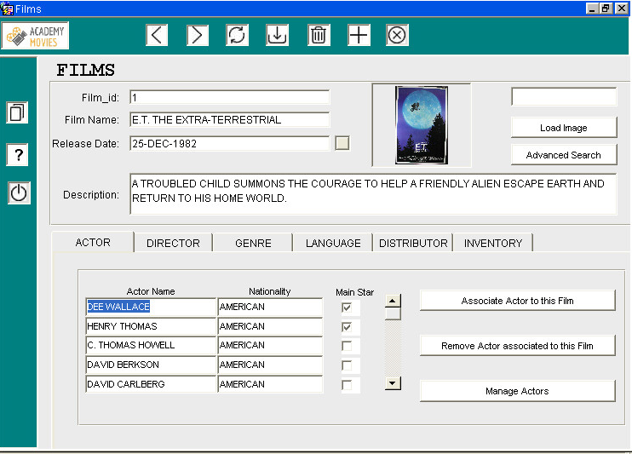

**Film_id** is automatically filled and cannot be edited.

**Film Name** is the name of the film.

**Release Date** is the date when the film was released.

**Description** is a brief description of the film.

The user can load a poster by clicking on “**Load Image**”.

The film form has the following tabs:

* Actor
* Director
* Genre
* Language
* Distributor
* Inventory

Actor, Director, Genre, Language, and Distributor tabs have three buttons:

* **Associate**: The user associate an existing actor/director/genre/language/distributor to the film.
* **Remove:** The user can remove a linked actor/director/genre/language/distributor associated to the film.
* **Manage actors/directors/genres/languages/distributors**: This button opens the respective form. For example, by clicking on “Manage Actors”, the Actors form is open and the user can create/delete/update an actor.

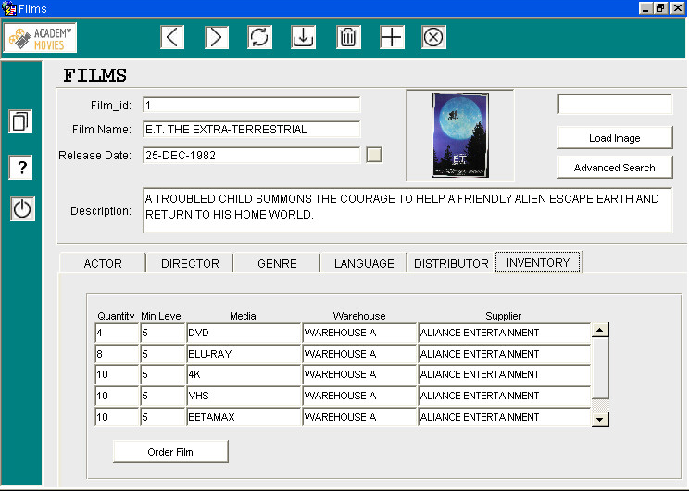

In the Inventory Tab the user can see the quantity and the minimum level for media and in which Warehouse the products are located.

# Advanced Search for Films



This form allows you to search by actor/director/genre or even any keyword in the film title. You can view all the films in the database too. If you double click a search result, it will take you back to the films form to give you the details of the film you selected.

# Actors

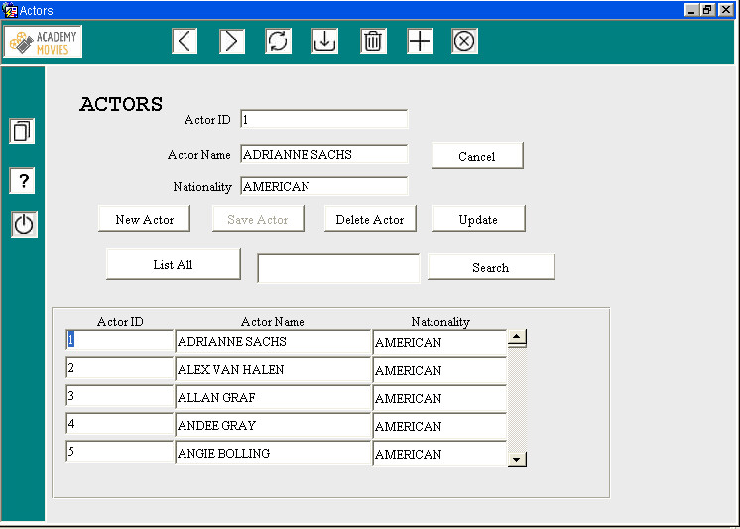

Actors form has the same functionalities of Genres form.

# Directors

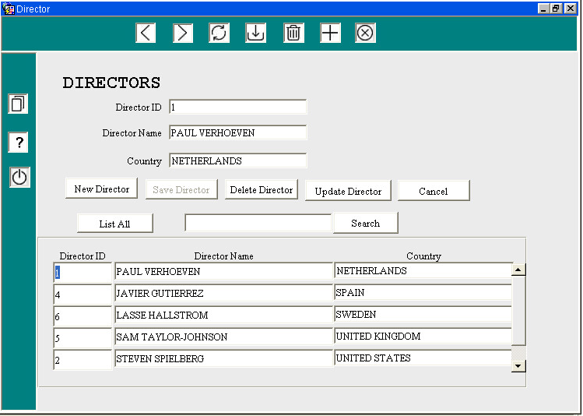

Directors form has the same functionalities of Genres form.

# Sales Submenu

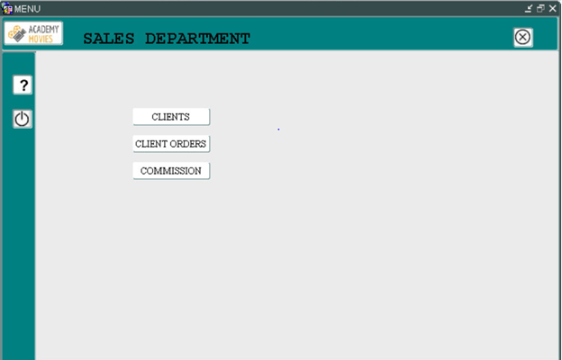

In the above submenu, you can click on any of the buttons to take you to that particular form.

# Accounting Submenu

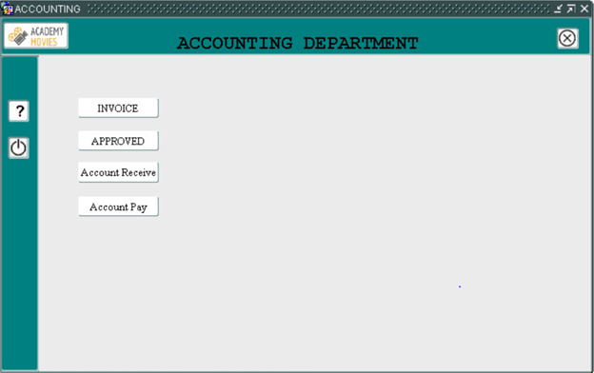

In the above submenu, you can click on any of the buttons to take you to that particular form.

# Client Order

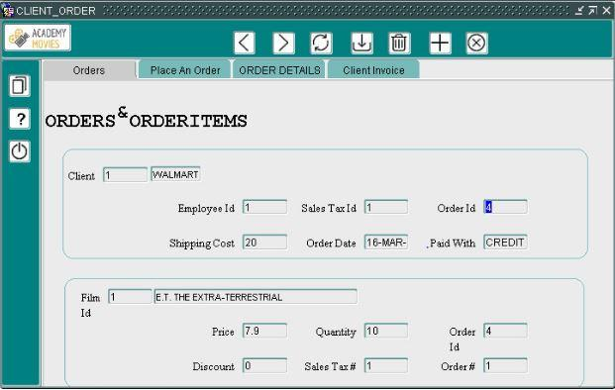

This is an orders and order items form. User can place an order, view order details, and view client invoices. Users can see the shipping cost, order date, and the payment method. The details about the films, quantity ordered, and discount can also be seen in the same form.

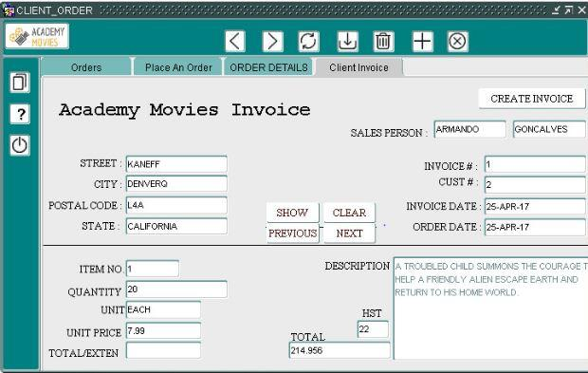

This is a client invoice form where users can see all the details about the orders, and the commission gets generated. After placing an invoice the quantity on hands is updated for the item.

# Commissions

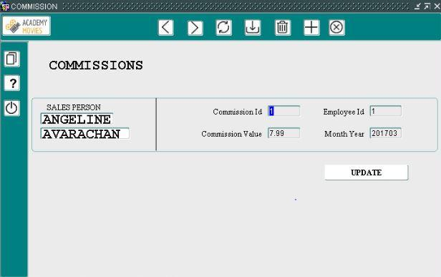

This is a form where users can see the commissions by an employee name, and by month and year. The user can also update the commission value.

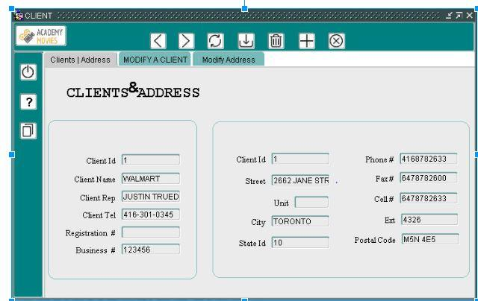

This is the client and client address form. Users can view, insert, update, or delete details about the clients. Users can see the address in the address tab, update it as per necessity.

# Approve Client

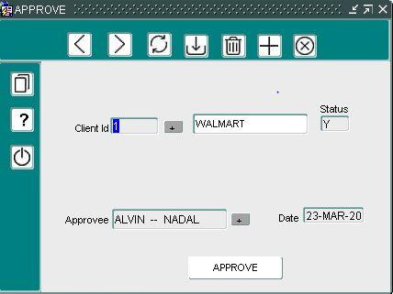

This form shows the user if the client is approved by Academy Movies.